Reg.# 2019-EE-383

University of Engineering & Technology Lahore

**Experiment # 1 Title:** Starting with MATLAB/MATLAB Refresher

**Equipment Required:** Personal computer (PC) with windows operating system and MATLAB software

### Theory:-

MATLAB is a powerful computing system for handling the calculations involved in scientific and engineering problems. The name MATLAB stands for *MATrix LABoratory,* because the system was designed to make matrix computations particularly easy.

One of the many things about MATLAB (and which distinguishes it from many other computer programming systems, such as C++ and Java) is that you can use it *interactively*. This means you type some commands at the special MATLAB prompt, and get the answers immediately. The problems solved in this way can be very simple, like finding a square root, or they can be much more complicated, like finding the solution to a system of differential equations. For many technical problems you have to enter only one or two commands, and you get the answers at once.

## MATLAB WINDOWS:-

|  |  |
| --- | --- |
| **Window** | **Purpose** |
| Command Window | Main window, enters variables, runs programs. |
| Figure Window | Contains output from graphic commands. |
| Editor Window | Creates and debugs script and function files. |
| Help Window | Provides help information. |
| Launch Pad Window | Provides access to tools, demos, and documentation. |
| Command History Window | Logs commands entered in the Command Window |
| Workspace Window | Provides information about the variables that are used. |
| Current Directory Window | Shows the files in the current directory |

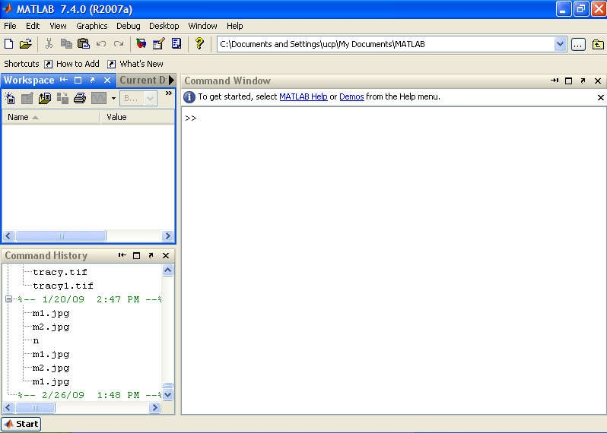

Workspace Window

Command Window

Command History Window

**Procedure:-**

1. To start MATLAB from Windows, double-click the MATLAB icon on your Windows desktop. When MATLAB starts, the MATLAB desktop opens as shown in Figure
   1. The window in the desktop that concerns us for this experiment is the Command Window, where the special >> prompt appears. This prompt means that MATLAB is waiting for a command. You can quit MATLAB at any time with one of the following:
      * Select Exit MATLAB from the desktop File menu.
      * Enter quit or exit at the Command Window prompt.
2. Once you have started MATLAB, try the following exercises in the Command Window.
3. Type 2+3 after the >> prompt, followed by Enter, i.e. press the Enter key, as indicated by *<*Enter*>*, below:

>>2+3 *<*Enter*>*

Commands are only carried out when you press Enter. The answer in this case is, of course, 5.

1. Next try the following:

>>3-2 *<*Enter*>*

>>2*3 *<*Enter*>*

>>1/2 *<*Enter*>*

>> 2ˆ3 *<*Enter*>*

>>2\1 *<*Enter*>*

symbols *, / and ˆ, are multiplication, division and exponentiation. The backslash means the denominator is to the left of the symbol and the numerator is to the right of the symbol; the result for the last command is 0.5. This operation is equivalent to 1/2.

1. Assign values to variables to do arithmetical operations with the variables.

(a) Enter the command a = 2, i.e. the MATLAB command line should look like this:

>>a = 2 *<*Enter*>*

The symbol a is called a *variable*. This statement *assigns* the value of 2 to a. (b)Now enter the statement

>>b = 3; *<*Enter*>*

The semicolon (;) prevents the value of b from being displayed.

1. The output format is fixed-point with 4 decimal digits (called short), which is the default format for numerical values. The format can be changed with the formatcommand. Once the format command is entered, all the output that follows is displayed in the specified format. Several of the available formats are listed and described in Table below.

### Display formats

|  |  |  |
| --- | --- | --- |
| **Command** | **Description** | **Example** |
| format short | Fixed-point with 4 decimal digits for:  *0.001 ≤ number ≤*1000 Otherwise display  format short e. | >> format short  >> 290/7  ans = 41.4286 |
| format long | Fixed-point with 14decimal digits. | >> format long  >> 290/7  ans = 41.428571428571431 |
| format short e | Scientific notation with 4 decimal digits. | >> format short e  >> 290/7  ans = 4.1429e+001 |
| format long e | Scientific notation with 15 decimal digits. | >> format long e  >> 290/7  ans =  4.142857142857143e+001 |
| format short g | Best of 5-digit fixed or floating point. | >> format short g  >> 290/7 |

|  |  |  |
| --- | --- | --- |
|  |  | ans = 41.429 |
| format long g | Best of I5-digit fixed or floating point. | >> format long g  >> 290/7  ans = 41.4285714285714 |
| format bank | Two decimal digits. | >> format bank  >> 290/7  ans = 41.43 |

1. ***ELEMENTARY MATH BUILT-IN FUNCTIONS***

In addition to basic arithmetic operations, expressions in MATLAB can include functions. MATLAB has a very large library of built-in functions. A function has a name and an argument in parentheses. For example, the function that calculates the square root of a number is sqrt(x). Its name is sqrt, and the argument is x.

Elementary math functions

|  |  |  |
| --- | --- | --- |
| **Function** | **Description** | **Example** |
| sqrt(x) | Square root. | >> sqrt(81)  ans = 9.00 |
| exp(x) | Exponential *(ex).* | >> exp(5)  ans = 148.41 |
| abs (x) | Absolute value. | >> abs (-24)  ans = 24.00 |
| log (x) | Natural logarithm.  Base e logarithm (In). | >> log(1000)  ans = 6.91 |
| log10(x) | Base 10 logarithm. | >> log10(1000)  ans = 3.00 |
| factorial (x) | The factorial function *x!*  *(x* must be a positive integer.) | >> factorial (5)  ans = 120.00 |

|  |  |  |
| --- | --- | --- |
| **Function** | **Description** | **Example** |
| sin(x) | Sine of angle *x (x* in radians). | >> sin(pi/6) ans = 0.5000 |
| cos(x) | Cosine of angle *x (x* in radians). | >> cos(pi/6) ans = 0.8660 |

|  |  |  |
| --- | --- | --- |
| tan (x) | Tangent of angle *x (x* in  radians). | >> tan(pi/6)  ans = 0.5774 |
| cot (x) | Cotangent of angle *x (.x* in  radians). | >> cot(pi/6)  ans = 1.7321 |

**Rounding functions**

|  |  |  |
| --- | --- | --- |
| **Function** | **Description** | **Example** |
| round (x) | Round to the nearest  integer. | >> round (17/5)  ans = 3 |
| fix(x) | Round towards zero. | >> fix (13/5)  ans = 2 |
| ceil(x) | Round towards infinity. | >> ceil (11/5) ans = 3 |
| floor (x) | Round towards minus  infinity. | >> floor(-9/4)  ans = -3 |
| rem(x,y) | Returns the remainder after  *x* is divided by *y.* | >> rem(13,5)  ans = 3 |
| sign(x) | Signum function. Returns 1 if  *x* > 0 , -1 if *x* < 0, and 0 if *x* =  0 | >> sign(5) ans = 1 |

## Rules About VariableNames

Variablenames:

* Can be up to 63 characters long
* Can contain letters, digits, and the underscore character
* Must begin With a letter.
* MATLAB is case sensitive; it distinguishes between uppercase and lowercase letters. For example, AA,Aa, aA, and aa are the names of four different variables.
* Avoid using the names of a built-in function for a variable (i.e. avoid using: cos, sin, exp, sqrt, etc.). Once a function name is used to define a variable, the function cannot be used.

# Problems:-

Solve the following problems in the Command Window.

1. Calculate:

35.7 * 64 - 73

a) 45 + 52

**Sol:**

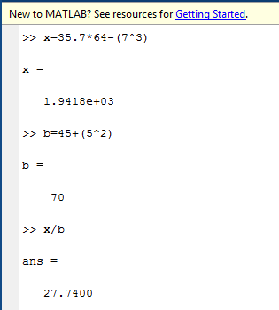

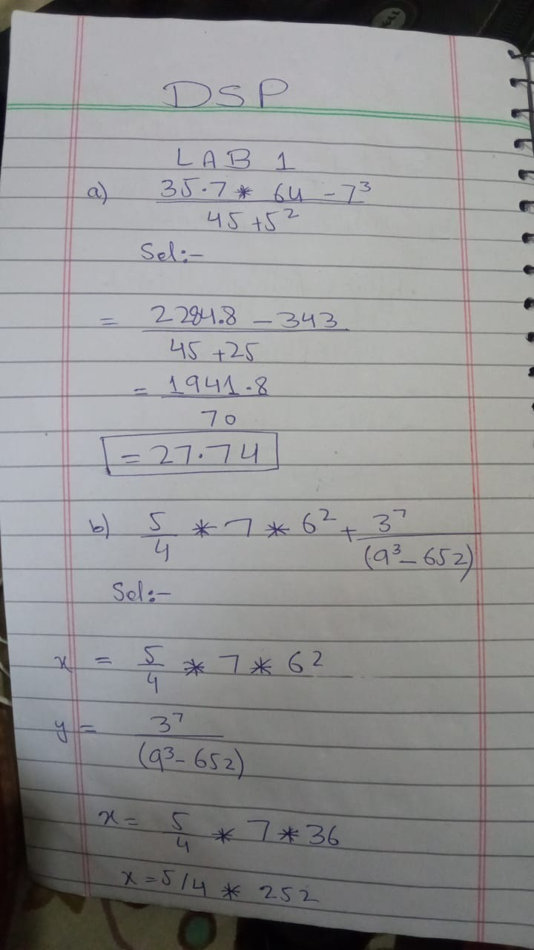

b) 5 4

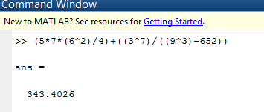* 7 *62

+ 37

(93 - 652)

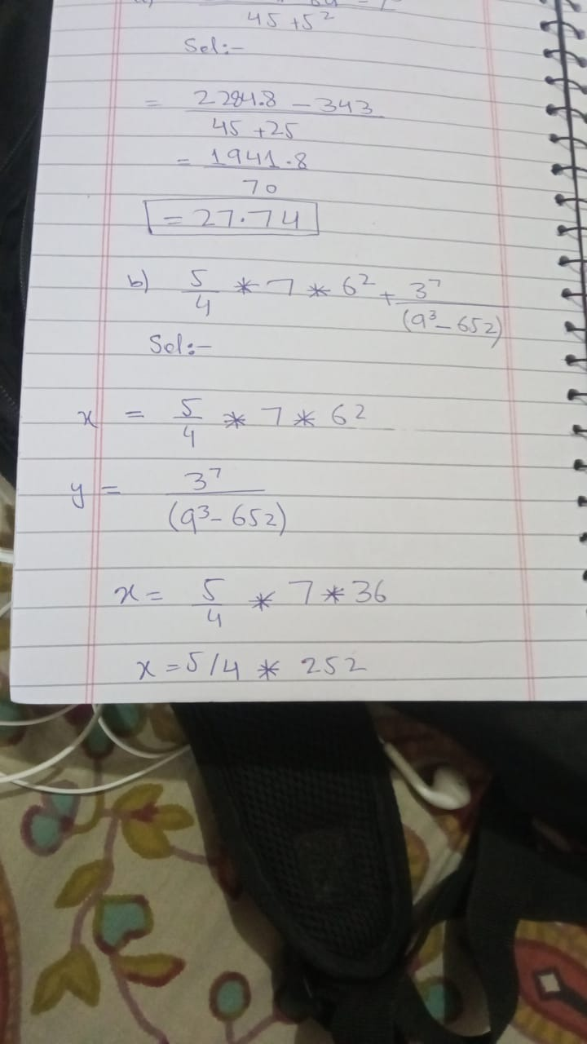

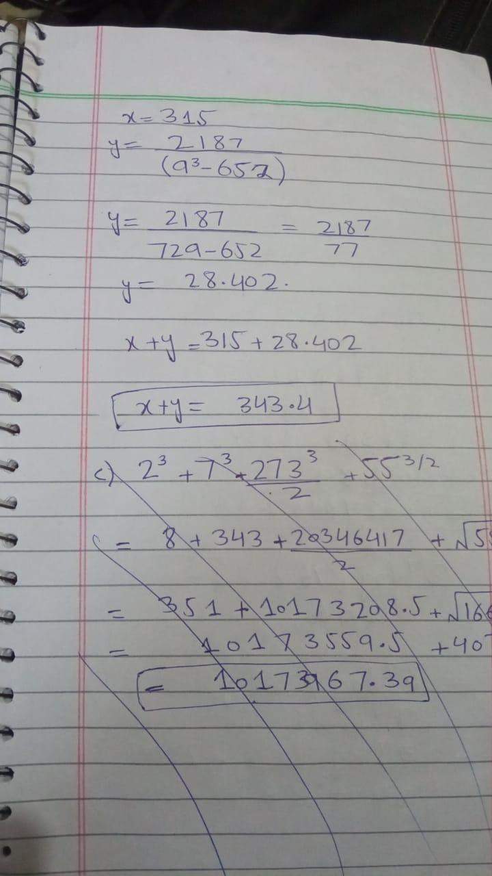

c) (2 + 7)3

+ 2732 / 3

2

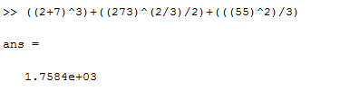+ 552

3

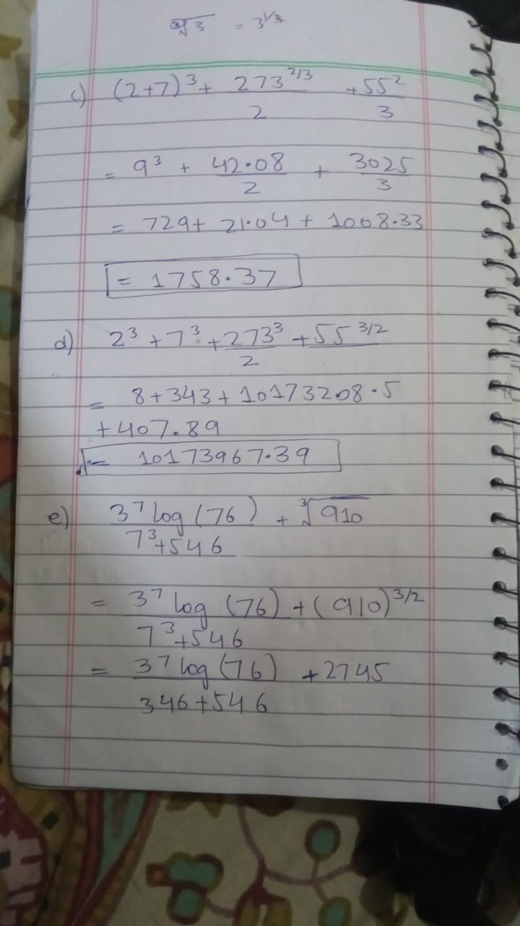

d) 23

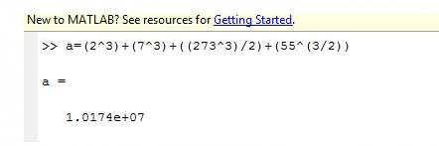+ 73 +

2733

2

+ 553 / 2

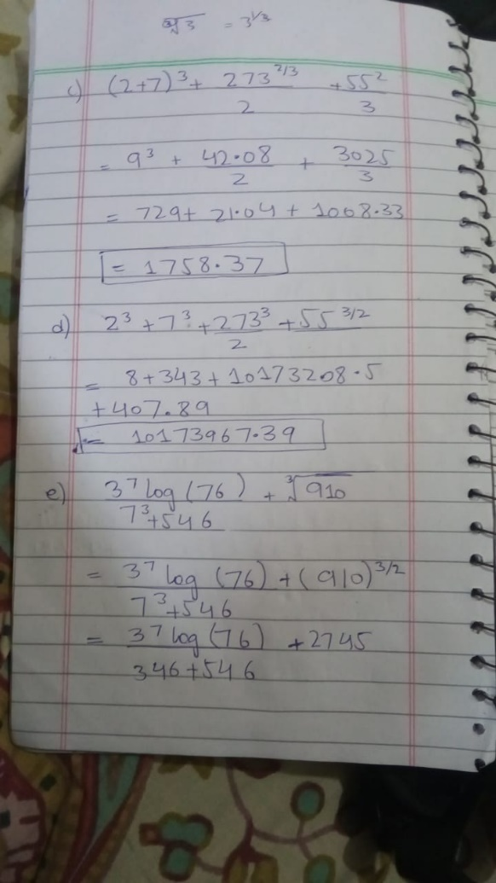

e) 37 log(76) +

3 910

73 + 546

f) 43* 4 250 + 23

*e*(45-33 )

tanæ *p* ln8ö

æ 5*p* ö æ 7*p* ö2

ç 6 ÷

1. cos2 ç ÷sinç ÷ + è ø

è 6 ø

è 8 ø

7

tanæ *p* ln8 ö

æ 5*p* ö2

æ 7*p* ö

ç 6 ÷

1. cosç ÷

è 6 ø

sin2 ç ÷ +

è 8 ø

è ø

7 * 5

2

1. Define the variable x as x = 13.5, then evaluate:

a) *x*3 + 5*x* 2 - 26.7*x* - 52

14*x*3

1. *e*3*x*
2. log *x*2 - *x*3
3. Define the variable x and z as x = 9.6, and z=8.1, then evaluate

3

ç ÷

* 1. *xz*2 - æ 2*z* ö5

3*x*

è

b) 443*z* +

2*x*3

ø

*e*- *xz*

(*x* + *z*)

1. Define the variable a, b, c, and d as:

a = 15.62, b =-7.08, c = 62.5 and d = 0.5(ab-c)

evaluate:

* 1. *a* +

*ab* * *c*

(*a* + *d* )2

*ad* + *cd*

*ab*

æ *d* ö

20 + 30

ç ÷

* 1. *de*è 2 ø + *a b*

*a* + *b* + *c* + *d*